City and Inner South Housing Affordability Analysis
Business Problem and Purpose
Sydney housing affordability is often assessed through headline property prices or rental costs in isolation. This can obscure an important issue: rental and ownership markets may be experiencing very different affordability pressures, even within the same locations.
Without analysing these markets together, it is difficult to determine whether worsening affordability is being driven by rising property prices, escalating rents, broader inflation, or pressure concentrated within particular housing segments.
This analysis therefore investigates how and where rental affordability has diverged from the ownership market across Sydney, with a primary focus on City and Inner South. It examines whether the pattern is isolated or widespread, identifies the dwelling and bedroom segments most exposed to rental pressure, and uses broader housing-market evidence to understand why the divergence emerged and persisted.
The objective is to move beyond the general conclusion that inner Sydney is expensive and identify the specific market dynamics behind the deterioration in rental affordability.
The analysis is structured in four layers:
- 2025-Q3 regional snapshot
- Historical and suburb-level rent-sales divergence
- Affordability and external market context
- Rental segment drivers

Layer 1 — 2025-Q3 Regional Snapshot

City and Inner South — Latest Position
Metric | 2025-Q3
Median Sales Price | ~$1.17M
Median Weekly Rent | $840
Price-to-Income Ratio | ~10.0x
Rent Burden | 37.3%
Total Sales | 1,783

Rent Burden represents median weekly rent as a percentage of the area's fixed 2021 Census median weekly household income.
The latest snapshot therefore shows a region where both renting and purchasing remain expensive, but rental affordability has become a particularly significant pressure.
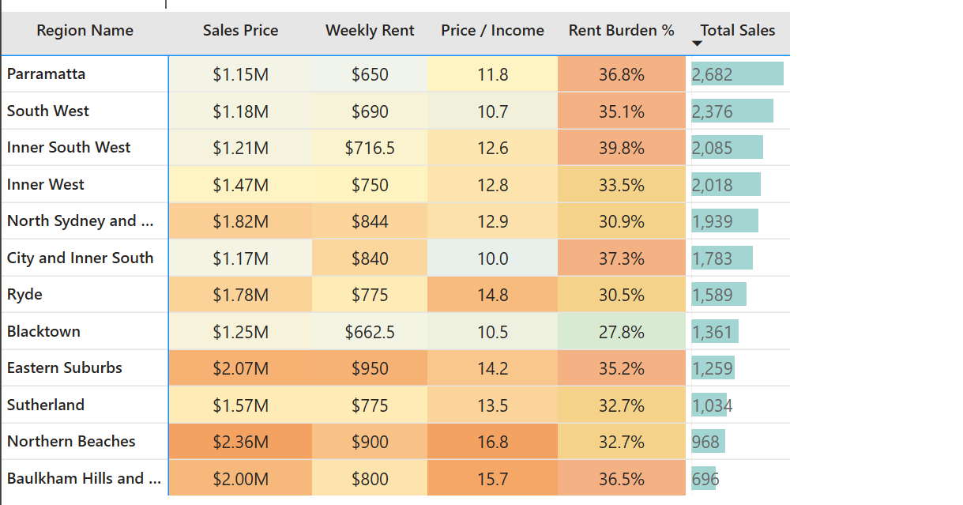
2025-Q3 snapshot of Sydney GMR Regions

This raises the central analytical question:
How did City and Inner South reach this position, and why did rental costs move so differently from sales prices?

Layer 2 — Rent vs Sales Growth Investigation
All cumulative growth figures use 2022-Q1 as the common baseline.
The historical pattern shows that a clear rent-sales divergence developed from around 2023 onward. Importantly, the divergence cannot be explained by one single sales-market condition.
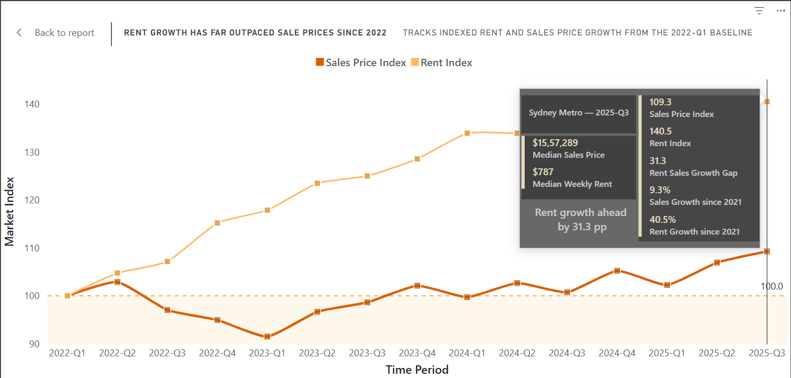
Rent vs Sales Growth Gap for Sydney GMR Region
From the common 2022-Q1 baseline, rent growth materially outpaced sales-price growth across Sydney Metro. By 2025-Q3, the Rent Index reached 140.5, compared with 109.3 for sales prices, creating a 31.3 percentage-point growth gap.
The divergence began to become pronounced from late 2022 into 2023. Sales prices fell below their baseline through much of 2022–23, reaching their lowest point around 2023-Q1, while rents continued to rise. Sales prices later recovered and exceeded their 2022-Q1 level, but this recovery was not sufficient to close the gap because rent growth remained substantially stronger.
By 2025-Q3, sales prices were approximately 9.3% above the 2022-Q1 baseline, while rents were approximately 40.5% higher. This shows that the current affordability pressure is not simply the result of falling property prices; rather, rents have followed a much stronger and more persistent growth path than the ownership market.

Three different mechanisms appear simultaneously.

1. Near-Stagnant Sales Prices + Very Strong Rent Growth
Zetland
Metric | 2025-Q3
Sales growth vs 2022-Q1 | +1.5%
Rent growth vs 2022-Q1 | +54.4%
Rent-sales gap | ~53 pp
Sales activity | 198 transactions

Zetland's median sales price remained almost unchanged from its 2022-Q1 level, while rent increased by more than 50%.
The 198 recorded sales transactions are important because the weak price growth did not occur in an inactive market.
Chippendale
- Sales growth: ~0%
- Rent growth: +58.8%
This again shows strong rental escalation without corresponding capital-price growth.
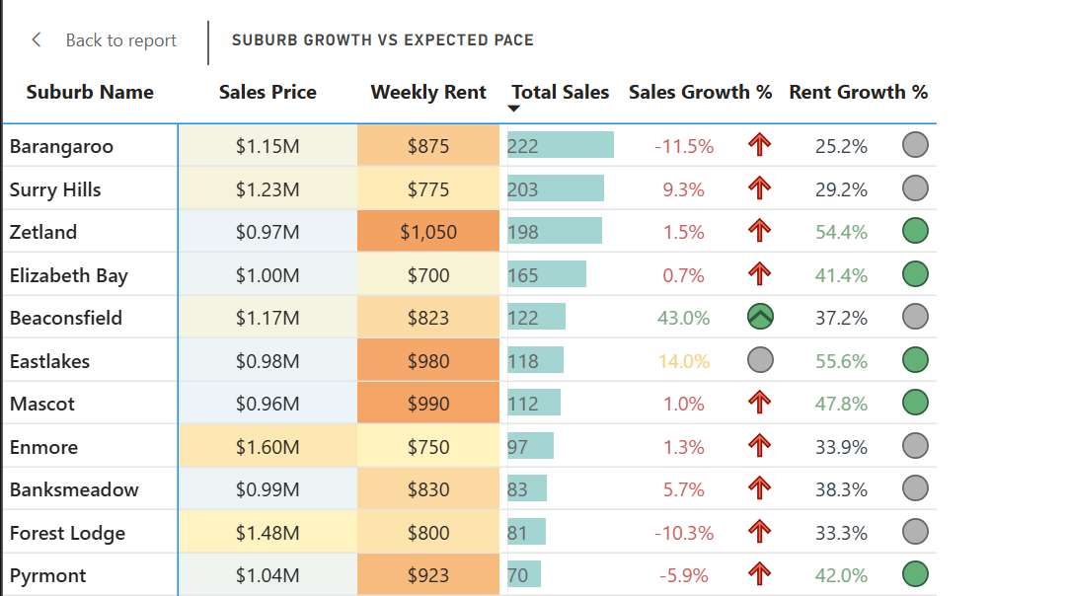
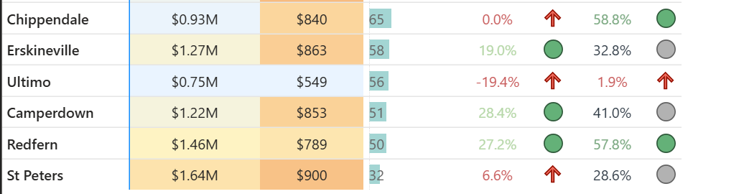
2025-Q3 Figures for the city and inner south region suburbs

2. Weak or Declining Sales Prices + Rising Rents
Barangaroo
- Sales growth: -11.5%
- Rent growth: +25.2%
- Sales activity: 222
Pyrmont
- Sales growth: -5.9%
- Rent growth: +42.0%
These suburbs show that rental escalation continued even where sales prices remained below their 2022-Q1 levels.

3. Sales Prices Growing — But Rents Growing Much Faster
Eastlakes
- Sales growth: +14.0%
- Rent growth: +55.6%
- Gap: ~42 pp
Redfern
- Sales growth: +27.2%
- Rent growth: +57.8%
Here, both sides of the housing market appreciated, but rental costs increased substantially faster.
Interpretation
The regional pattern therefore cannot simply be described as:
“Sales prices fell while rents increased.”
Rental growth materially exceeded sales-price growth across suburbs where sales prices:
- stagnated;
- declined; and
- increased strongly.
This indicates that the divergence is primarily a rent-led phenomenon rather than the mechanical result of weak property-price growth.

Evidence That the Pattern Extends Beyond City and Inner South

Inner South West — 2025-Q3
- Median sales growth: ~+15.4%
- Median rent growth: ~+48.1%
- Median rent-sales gap: ~34 pp
- Sales activity: ~2,085

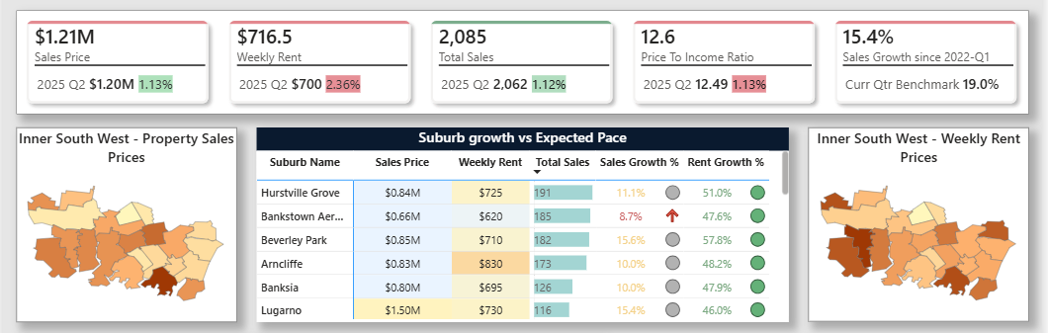
Inner south west housing postal level details

Parramatta — 2025-Q3
- Median sales growth: ~+19.8%
- Median rent growth: ~+49%
- Median rent-sales gap: ~30 pp
- Sales activity: ~2,682
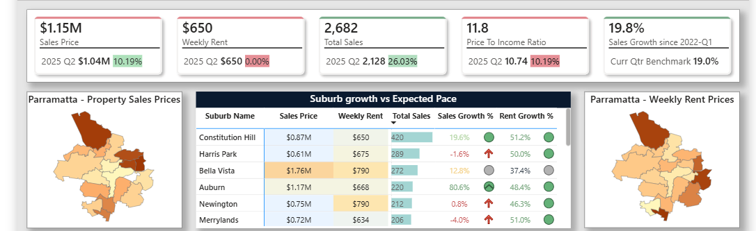
Parramatta Housing Postal level Details 2025-Q3

Both regions continued to show strong rental growth even as sales activity recovered.
The City and Inner South result therefore appears consistent with a broader Sydney-wide rental-market phenomenon, although the magnitude and individual suburb behaviour differ.

Layer 3 — Affordability and Market Context

Rent Growth Was Not Simply General Inflation
The strongest temporal affordability measure in the analysis is Rent vs CPI, because household income is fixed at its 2021 Census level.
Period | Median Rent vs CPI
2022-Q2 | +5%
2023-Q1 | +17%
2024-Q1 | +26%
2025-Q1 | +28%
2025-Q3 | +24%

By 2024-25, rents in the typical suburb were approximately one-quarter above the level they would have reached if they had merely followed general inflation. This measure is not rent growth itself; it represents the gap between actual rent and the CPI-implied rent path from the baseline.
Therefore, the divergence represents more than normal economy-wide price increases.

Fixed-Income Affordability Benchmark
Median Rent Burden increased approximately from:
26% in 2022-Q2 → 37% in 2025-Q3
while Price-to-Income moved approximately from:
8.7x → 9.4x
Because both use fixed 2021 household income, they should not be interpreted as contemporary income-adjusted affordability measures. However, they show that rental costs moved much further against the same benchmark than purchase prices did.

What Was Happening Around the 2023 Divergence?
The external market evidence provides a plausible context for why the divergence became much more pronounced around late-2022 and early-2023.
1. A Rapid Post-Lockdown Rental-Demand Shock
Australia experienced an unusually large rebound in overseas migration following the reopening of international borders. Net overseas migration reached 518,000 people in 2022–23, while migrant arrivals increased sharply as international movement normalised after the pandemic (Australian Bureau of Statistics [ABS], 2024).
A substantial component of this rebound came from temporary visa holders, particularly international students. The return of international students and other temporary migrants increased rental demand in major capital cities, with inner-city rental markets particularly exposed to the reopening of international borders (Hanmer & Marquardt, 2023).
The migration surge was also amplified by unusually low departures. Pandemic-era disruptions and visa extensions meant that departures initially recovered more slowly than arrivals, contributing to the unusually large increase in net overseas migration (Gamlen & McDonald, 2026).
At the same time, rental demand was already being affected by changes in household formation. Average household size declined during the pandemic as people sought more living space, creating an estimated 120,000 additional households nationally and increasing the amount of housing required even before migration had fully recovered (Hanmer & Marquardt, 2023).
What this points to
The timing is consistent with a market experiencing:
more people + more households + limited spare rental capacity
This points to demand pressures rising faster than the rental market’s ability to absorb them, allowing rents to accelerate independently of property sales prices.
The timing also aligns with the City and Inner South data, where the rent-sales divergence became substantially more pronounced from around 2023.
2. Why the Pressure Persisted
The initial migration rebound helps explain the sudden increase in rental demand, but it does not by itself explain why rental pressure remained elevated through 2024 and 2025.
Broader Australian construction conditions were not expanding quickly enough to accommodate the increase in underlying housing demand. New home commencements fell to approximately 163,836 nationally in 2023, the lowest level since 2012 (Housing Industry Association [HIA], 2024).
More recent HIA analysis suggests that the imbalance has persisted, with annual home starts remaining below the level required to accommodate continuing population growth (HIA, 2026).
At the same time, the post-pandemic migration surge did not simply disappear after its initial peak. Migration gradually normalised over several years, meaning that although annual net migration subsequently declined, the cumulative population increase still needed to be accommodated within the housing system (Gamlen & McDonald, 2026).
What this points to
The rental market appears to have experienced more than a short-term demand spike.
Instead, the evidence is consistent with:
a rapid increase in housing demand entering a market where new housing supply could respond only gradually.
This provides a plausible explanation for why the rent-sales divergence persisted rather than quickly correcting after the initial reopening period.
3. Very Low Vacancy Rates Reinforced Rental Competition
Sydney's rental vacancy rate began falling sharply from late 2021 and into 2022 as rental demand recovered. The RBA identified declining vacancy rates alongside rapidly increasing advertised rents as evidence of substantial tightening in Australia's rental market (Hanmer & Marquardt, 2023).
The tight conditions did not immediately disappear. Sydney vacancy rates reportedly remained around 1.4%–1.8% during 2025 (Urban Renter's Agent, 2026) and remained around 1.5%–1.7% during parts of 2026 (Christopher, 2026).
Low vacancy indicates that relatively few rental properties are available compared with the number of households seeking accommodation.
What this points to
The broader market mechanism is consistent with:
strong rental demand + insufficient available housing → low vacancy → increased competition for rentals → sustained upward pressure on rents
Persistently low vacancy therefore provides an important connection between the migration and supply evidence and the rental-price growth observed in the dashboard.
It also helps explain why rents could continue increasing in suburbs where sales prices were stagnant or declining: rental-market competition remained intense regardless of what was occurring in the ownership market.
4. Interest Rates Created Different Pressure on the Ownership Market
The rental-market tightening occurred at approximately the same time that the ownership market was facing a very different financial shock.
The sharp rise in interest rates from 2022 substantially increased mortgage servicing costs and reduced the amount prospective buyers could afford to borrow. Estimates cited in property-market analysis suggest that borrowing capacity fell materially as mortgage rates and lender serviceability requirements increased (Johnson, 2026).
Higher financing costs affected the ownership market through several channels:
- prospective buyers could borrow less;
- mortgage repayments increased;
- purchasing affordability weakened;
- financing costs increased for property investors; and
- property prices experienced downward or moderating pressure during parts of 2022–23 (Johnson, 2026).
Investors were also exposed to substantially higher mortgage and holding costs. Industry analysis reported a weakening in investor participation as higher financing costs affected the economics of holding or purchasing investment property (Property Investment Professionals of Australia [PIPA], 2026).
This provides a plausible explanation for why rents could rise strongly even when sales prices were stagnant, declining or growing considerably more slowly.
The important phenomenon is therefore not simply that rents increased while sales prices weakened. Rather, the rental and ownership markets were being influenced by different economic forces at the same time, allowing their growth trajectories to separate substantially after 2022.
What this points to
The rent-sales divergence can therefore be interpreted as two different market forces operating simultaneously:
Rental market:
strong population/household demand + very low vacancies + insufficient new supply → upward rent pressure
Ownership market:
higher interest rates + reduced borrowing capacity + higher servicing costs → constrained purchasing power and weakened sales-price momentum, particularly through 2022–23.
This provides a plausible economic mechanism for suburbs such as Zetland, Barangaroo and Pyrmont, where rental prices increased strongly despite little or negative sales-price growth.
It may also help explain why the divergence remained visible even after property prices began recovering.

Why City and Inner South May Be Particularly Exposed
City and Inner South has substantial exposure to the type of housing likely to absorb returning inner-city renters, including smaller apartments and units. The segment analysis strongly supports this market structure.
Flat/units account for approximately:
76% of reported new rental bonds
and cover all 17 analysed postcodes.
Bedroom-level activity is also concentrated in smaller properties:
Bedroom Segment | New Bonds | Rent Burden | Rent vs CPI
1BR | 5,837 | 32.2% | +7.9%
2BR | 3,267 | 42.3% | +41.5%
3BR | 581 | 56.0% | +87.6%

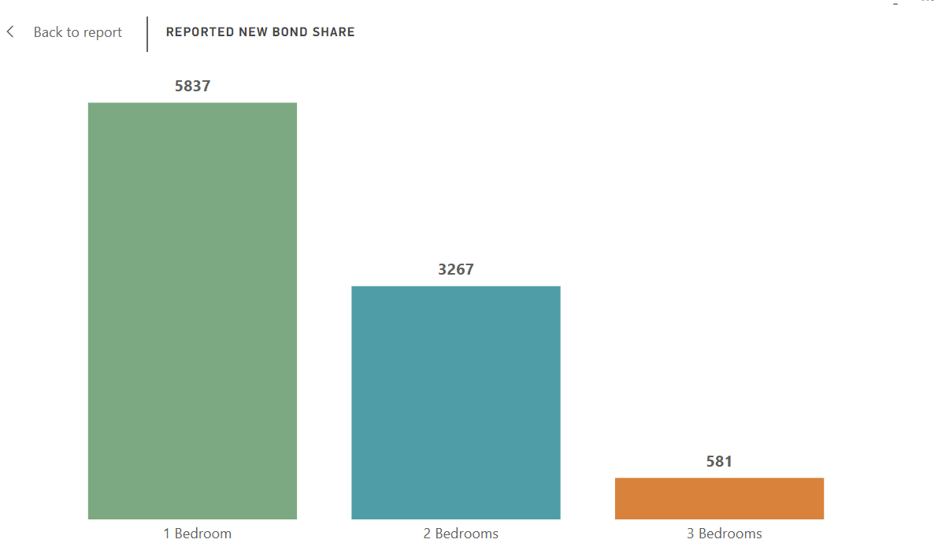
New Bond Share by Bedroom Counts 2025-Q3: City and Inner South region

City and Inner South is also an inner-city employment and education hub. The post-border-reopening return of international students and other temporary migrants is therefore consistent with stronger demand for the smaller apartment stock that dominates the region's rental market.
The analysis does not establish that students specifically caused the 1BR and 2BR results. Instead, the external demographic evidence provides a plausible explanation for why pressure appearing in these segments would be particularly relevant in this region.

Layer 4 — Segment Drivers
The segment analysis distinguishes between severity of pressure × market coverage × rental activity. This is important because the segment with the highest rent does not necessarily contribute most to rental pressure.

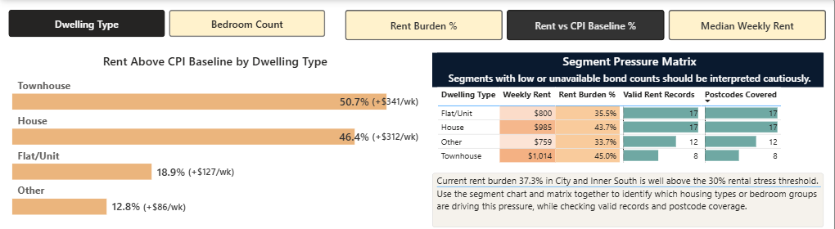
2025-Q3 snapshot for City and Inner South region by dwelling Types

Dwelling Type
1. Broadest Regional Driver — Flat/Unit
Metric | Flat/Unit
Median Weekly Rent | $800
Rent Burden | 35.5%
Rent vs CPI | +18.9%
Postcodes Covered | 17
New Bonds | 8,460
Approx. Bond Share | ~76%

Flat/units are not the most severely burdened dwelling type, but they dominate the market by scale and geographic coverage.
Their Burden Index reaches approximately 138 by 2025-Q3, meaning burden is roughly 38% above its 2022-Q1 level. They therefore represent the broadest regional source of rental pressure.
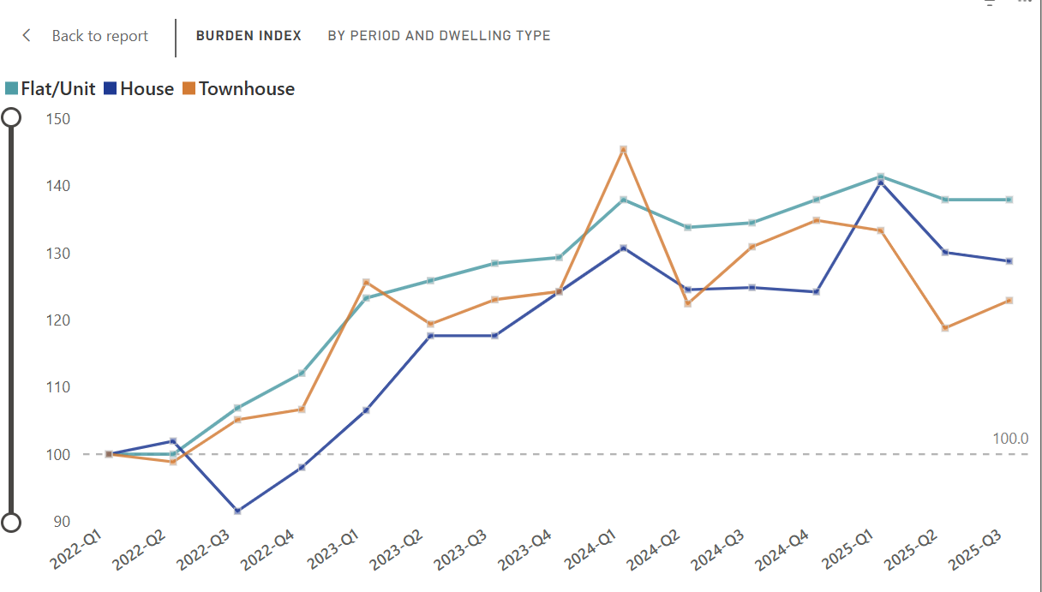
Rent Burden Index Growth since 2022-Q1 by Dwelling Types

2. Houses — Higher Severity, Lower Market Volume
Metric | House
Median Weekly Rent | $985
Rent Burden | 43.7%
Rent vs CPI | +46.4%
New Bonds | 816

House renters experience considerably greater affordability pressure, but houses represent only around 7% of reported new rental activity.
They therefore represent an acute but smaller-volume pressure segment.

Bedroom-Level Pressure
Bedroom count reveals an especially clear relationship:
As dwelling size increases, affordability pressure rises sharply while market volume falls.
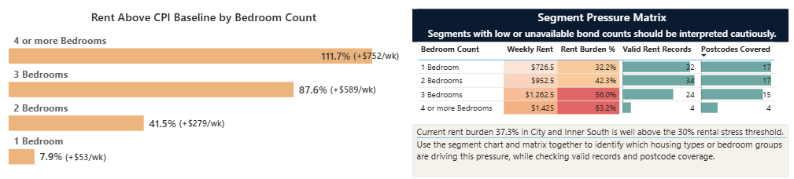
2025-Q3 snapshot for City and Inner South region by Bedroom Count

1 Bedroom — Broadest Exposure
- 5,837 new bonds
- all 17 postcodes
- Rent Burden: 32.2%
- Burden Index: ~145
The absolute affordability burden is lower, but the segment affects a very large portion of the rental market.
2 Bedroom — Strongest Combination of Scale and Severity
- Rent Burden: 42.3%
- Rent vs CPI: +41.5%
- New Bonds: 3,267
- Coverage: 17 postcodes
The 2BR market therefore represents one of the clearest intersections of:
high exposure + substantial affordability pressure + strong geographic coverage.
3 Bedroom — Acute Pressure
- Median rent: $1,262.50
- Rent Burden: 56.0%
- Rent vs CPI: +87.6%
- New Bonds: 581
- Coverage: 15 postcodes
Three-bedroom rentals affect fewer households entering new leases, but those households face substantially greater affordability pressure. By 2025-Q3, the 1-bedroom segment had the highest Burden Index at ~145, meaning its rent burden was about 45% above its 2022-Q1 level, while 2BR and 3BR were around 136–137 and 4+BR around 119. The key insight is that 1BR experienced the strongest deterioration from its own starting point, but 3BR faced the greatest credible absolute pressure, with rent burden reaching 56%, compared with 42.3% for 2BR and 32.2% for 1BR.
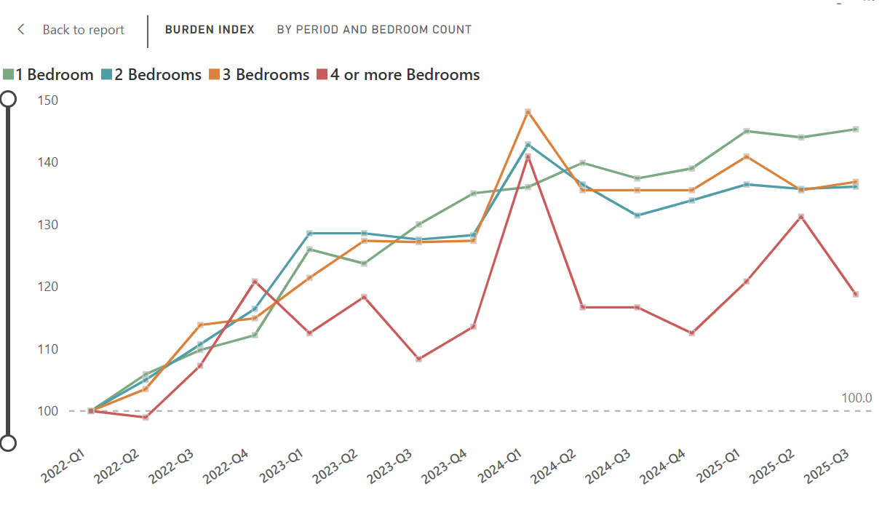
Burden Index by Different Bedroom Types for City and Inner South Region suburbs
2021 Household Context
The 2021 Census provides additional structural context:
Household Metric | 2021
Median Weekly Household Income | $2,255
Average Household Size | 2.07 persons
Persons per Bedroom | 1.09
Median Monthly Mortgage | $2,800
An average household size of approximately two people is consistent with the importance of smaller rental configurations within the region.
This does not establish household size as the cause of demand for 1BR and 2BR properties, but it strengthens the interpretation that affordability pressure within these high-volume segments is regionally important.

Overall Analytical Story
The evidence points to a housing affordability problem that is more specific than simply saying that inner Sydney is expensive.
1. A clear rent-sales divergence emerged
From around 2023, rents began rising substantially faster than sales prices.
The pattern appears under multiple sales-market conditions:
- stagnant sales prices;
- falling sales prices; and
- rising sales prices.
This means weak capital growth alone cannot explain the divergence.
2. The phenomenon extends beyond City and Inner South
Parramatta and Inner South West show similarly large rent-sales gaps, indicating that the pattern forms part of a broader Sydney rental-market shift rather than an isolated local anomaly.
3. Rental growth materially exceeded inflation
By 2024-25, median suburb rents were approximately one-quarter above their CPI-implied trajectory.
The rental escalation was therefore substantially stronger than general price inflation.
4. External conditions are consistent with the timing of the divergence
The observed pattern coincided with:
post-border migration rebound → additional household demand → very low rental vacancies → inadequate housing supply response
while simultaneously:
rapid interest-rate increases → reduced borrowing capacity → increased mortgage servicing costs → weaker conditions for purchasers
These opposing pressures provide a plausible explanation for why rent and sales markets could increasingly separate after 2022.
5. City and Inner South's housing composition amplified the relevance of the rental shock
The region's rental market is heavily concentrated in:
- flats and units;
- 1-bedroom properties; and
- 2-bedroom properties.
These are also the segments most exposed to high-volume rental demand.
Flat/units alone account for approximately three-quarters of reported new rental bonds, while 1BR and 2BR properties together account for the overwhelming majority of bedroom-level activity.
6. Rental pressure has two distinct dimensions
Broad pressure:
Flat/units and smaller 1–2BR dwellings affect the largest portion of the rental market.
Acute pressure:
Larger dwellings affect fewer renters but carry substantially higher affordability burdens, with 3BR rent reaching 56% of the fixed 2021 household-income benchmark and approximately 88% above its CPI-implied level.

Data Sources

Rent and Sales Datasets
Primary market data for residential rentals and property sales were collected from the NSW Department of Communities and Justice (DCJ). The dataset comprises quarterly spreadsheets covering 15 consecutive quarters, ranging from Issue 139 (March 2022 quarter) through Issue 153 (September 2025 quarter).
Scope & Metrics:
The rental datasets capture total rental bond lodgements, median weekly rent prices ($), and 12-month percentage changes segmented by property type (e.g., 1/2/3+ bedroom flats/houses) across Local Government Areas (LGAs) and postcode zones in New South Wales. Sales datasets detail quarterly median residential sale prices and transaction volumes across Greater Sydney and Rest of NSW regions.

Census 2021 Data
Australian Bureau of Statistics. (2021). Census of Population and Housing: General Community Profile, New South Wales, Suburbs and Localities (SAL). ABS. abs.gov.au

Consumer Price Index Data
Australian Bureau of Statistics. (2026, June). Consumer Price Index, Australia. ABS. https://www.abs.gov.au/statistics/economy/price-indexes-and-inflation/consumer-price-index-australia/latest-release.

Supporting Article Sources
Australian Bureau of Statistics. (2024, March 21). Overseas migration, 2022–23 financial year. https://www.abs.gov.au/statistics/people/population/overseas-migration/2022-23-financial-year
Christopher, L. (2026, July 15). National vacancy rate rises to 1.3% | SQM Research. Property Update. https://propertyupdate.com.au/rental-vacancy-rates/
Gamlen, A., & McDonald, P. (2026). The migration splash: Why Australia’s net overseas migration surged and fell after COVID-19 (ANU Migration Hub Insights No. 26/1). The Australian National University. https://migration.anu.edu.au/sites/default/files/2026-02/The%20Migration%20Splash%20ANU%20Insights%20Briefing%2030.1.26.pdf
Hanmer, F., & Marquardt, M. (2023, April 24). New insights into the rental market. Reserve Bank of Australia Bulletin. https://www.rba.gov.au/publications/bulletin/2023/jun/new-insights-into-the-rental-market.html
Housing Industry Association. (2024). New home commencements in 2023 were the lowest since 2012. https://hia.com.au/our-industry/newsroom/economic-research-and-forecasting/2024/04/new-home-commencements-in-2023-were-the-lowest-since-2012
Housing Industry Association. (2026). Australia’s housing shortage to worsen as home building falls behind population growth. https://hia.com.au/our-industry/newsroom/economic-research-and-forecasting/2026/06/australias-housing-shortage-to-worsen-as-home-building-falls-behind-population-growth
Urban Renter’s Agent. (2026). Rental vacancy rate Sydney 2026 guide. https://urbanrenters.com.au/blog/rental-vacancy-rate-sydney-2026/

